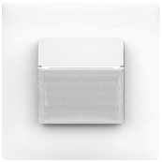
Tender text

Motion/presence detector theMura S180 Slave UP WH
Order No. white: 2060660

Features:
- Passive infrared motion/presence detector for wall mounting in flush-mounted box
- Cover in Theben design
- Slave device for the extension of the detection area of theMura detectors
- Rectangular detection area 170°, max. 14 m x 17 m
- Area restriction in scope of delivery
- Integrated button (can be deactivated)
- Fully or semi-automatic operation, switchable (can be set at master)
- Staircase light function (can be set at master)
- Extended function (can be set at master)
- Ready for immediate use due to factory presetting
- Test mode for checking the detection area

Technical data:
Operating voltage: 230 V AC
Frequency: 50 – 60 Hz
Power consumption: approx. 0.4 W
Radial detection area: 12 x 10 m
Tangential detection area: 14 x 17 m
Installation height Mh: 0.8 – 1.2 m
Protection rating: IP20
Operating temperature: -15 °C to +45 °C
Dimensions: 85 x 85 mm, installation depth 37 mm
Installation: wall mounting in flush-mounted box size 1

