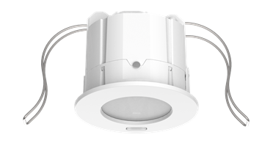
Tender text

Presence sensor PlanoSpot 360 DALI-2 S DE WH
Order No. white: 2030190 (PlanoSpot 360 DALI-2 S DE WH)

Features:
- Passive infrared presence sensor DALI-2 for ceiling installation
- This device provides information about presence and brightness in the form of a DALI telegram in line with IEC 62386 Part 303/304.
- Square detection area 360°, moving up to 64 m² (8 m x 8 m)
- 2 instances for presence - detection zone standard/reduced
- Optics can be tilted to adjust the detection area
- 3 mixed light measurements
- 4 instances for brightness - interior/centre/window/integral
- Easy to calibrate brightness measurement
- Test mode for checking function and detection area
- Configurable detection sensitivity
- Can be configured via DALI bus or remote control
- The «theSenda S» or «theSenda B» user remote controls can be used to dim or switch the lamps, to control the blinds, or to execute additional functions via the higher-level control.
- Flat design with interchangeable bezel frame in different colours
- This device corresponds to EN 60669-2-5 and IEC 62386-101/103/303/304

Technical data:
Operating voltage: DALI (in accordance with IEC 62386-101): 10 V – 22.5 V
Power input: max. 10 mA
Stationary detection area: 4.5 m x 4.5 m (IH 3 m)
Detection area walking: 7.0 m x 7.0 m (IH 3 m)
Recommended installation height IH: 2.0 – 3.0 m/max. 3.5 m
Light measurement: approx. 10 – 10,000 lux
Protection rating: IP20
Operating temperature: 0 °C to +50 °C
Dimensions: Ø 76 mm, installation depth 69 mm
Connection type: Plug-in terminal / 0.5 - 1.5 mm²
Installation: Ceiling installation with springs
Installation: Surface mounting on ceilings possible with back box 75B (option)

Optional accessories:

theSenda B universal remote control
User remote control with integrated lux meter.
Remote control for installers: The free theSenda Plug app (for iOS/Android) is easy to use for commissioning or adjusting the parameters. Parameter sets can be saved and named in a customer-specific way and exported for archiving, for instance via email.

Order No.: 9070985

theSenda P service remote control
Order No.: 9070910

theSenda S user remote control
Order No.: 9070911

Back box 75B
Order no. white: 9070796 (back box 75B WH)
Order No. black: 9070824 (back box 75B BK)

Bezel frame PlanoCover 76
Order No black: 9070977 (PlanoCover 76 BK)
Order No. silver: 9070978 (PlanoCover 76 SR)

